PhotoPrism® Digital Asset Management
PhotoPrism® is an AI-powered app for browsing, organizing & sharing your photo collection. It makes use of the latest technologies to tag and find pictures automatically without getting in your way. You can run it on your local computer, a private server, or in the cloud.

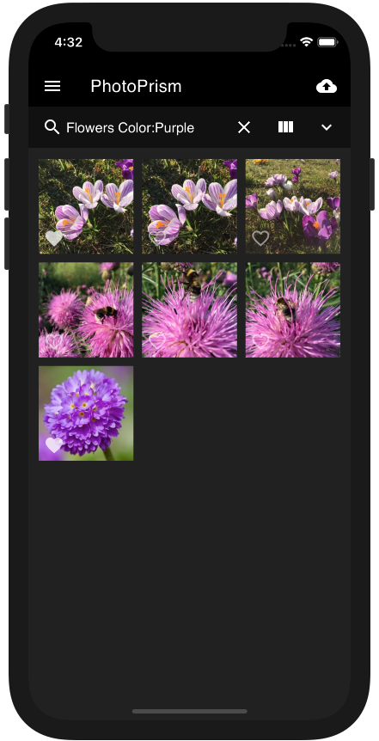
Feature Overview
Browse all your photos and videos without worrying about RAW conversion, duplicates or video formats
Easily find specific pictures using powerful search filters
Play Live Photos™ and short videos by hovering over them in albums and search results
Includes four high-resolution world maps with automatic image clustering based on the zoom level
Metadata is extracted and merged from Exif, XMP, and other sources such as Google Photos
Automatic classification of pictures based on their content and location
Detection and recognition of faces using Google TensorFlow
WebDAV clients such as Microsoft's Windows Explorer and Apple's Finder can connect directly to PhotoPrism, allowing you to open, edit, and delete files from your computer as if they were local
Privacy-friendly: No data is ever sent to Google, Amazon, Facebook, or Apple unless you explicitly upload files to one of their services

Broad File Format Support
PhotoPrism supports indexing, viewing, and converting most common image, video, and RAW file formats, including JPEG, PNG, GIF, BMP, HEIF, HEIC, MP4, MOV, WebP, and WebM. TIFF is partially supported without extensions like GeoTIFF. The internally used image format is JPEG. JPEG XL support is planned as soon as it is generally available and enough compatible tools exist.
Converting RAW files is possible with Darktable and RawTherapee. On a Mac, RAW files can also be converted with Apple’s Sips. Our goal is to provide first-class support for all RAW formats, regardless of camera make and model.
Video formats supported by FFmpeg can be transcoded to MPEG-4 AVC for maximum browser compatibility. Still images for thumbnail creation can be extracted from most videos as well.

Format | Description | Type | Extensions
BMP | Bitmap | Image | .bmp
GIF | Graphics Interchange Format | Image | .gif
HEIF | High Efficiency Image File Format | Image | .avci, .avcs, .avif, .avifs, .heic, .heics, .heif, .heifs
JPG | Joint Photographic Experts Group (JPEG) | Image | .jfi, .jfif, .jif, .jpe, .jpeg, .jpg, .thm
MPO | Stereoscopic JPEG (3D) | Image | .mpo
PNG | Portable Network Graphics | Image | .pn, .png
TIFF | Tag Image File Format | Image | .tif, .tiff
WEBP | Google WebP | Image | .webp
RAW | Unprocessed Sensor Data | Raw | .3fr, .ari, .arw, .bay, .cap, .cr2, .cr3, .crw, .data, .dcr, .dcs, .dng, .drf, .eip, .erf, .fff, .gpr, .iiq, .k25, .kdc, .mdc, .mef, .mos, .mrw, .nef, .nrw, .obm, .orf, .pef, .ptx, .pxn, .r3d, .raf, .raw, .rw2, .rwl, .rwz, .sr2, .srf, .srw, .x3f
AAE | Apple Image Edits XML | Sidecar | .aae
JSON | Serialized JSON Data (Exiftool, Google Photos) | Sidecar | .json
MD | Markdown Formatted Text | Sidecar | .markdown, .md
TXT | Plain Text | Sidecar | .txt
XML | Extensible Markup Language | Sidecar | .xml
XMP | Adobe Extensible Metadata Platform | Sidecar | .xmp
YML | Serialized YAML Data (Config, Metadata) | Sidecar | .yaml, .yml
3G2 | Mobile Multimedia Container (CDMA2000) | Video | .3g2
3GP | Mobile Multimedia Container (3G) | Video | .3gp
ASF | Advanced Systems Format | Video | .asf
AV1 | AOMedia Video 1 | Video | .av1
AVC | Advanced Video Coding (H.264, MPEG-4 Part 10) | Video | .avc
AVI | Microsoft Audio Video Interleave | Video | .avi
FLV | Adobe Flash | Video | .f4v, .flv
HEVC | High Efficiency Video Coding (H.265) | Video | .hevc
MJPG | Motion JPEG | Video | .mjpeg, .mjpg
MKV | Matroska Multimedia Container | Video | .mkv
MOV | Apple QuickTime | Video | .mov, .qt
MP2 | MPEG 2 (H.262) | Video | .mp2, .mpv
MP4 | Multimedia Container (MPEG-4 Part 14) | Video | .m4v, .mp, .mp4
MPG | Moving Picture Experts Group (MPEG) | Video | .mpeg, .mpg
MTS | Advanced Video Coding High Definition (AVCHD) | Video | .mts
OGV | Ogg Media (OGG) | Video | .ogg, .ogv, .ogx
VVC | Versatile Video Coding (H.266) | Video | .vvc
WEBM | Google WebM | Video | .webm
WMV | Windows Media | Video | .wmv

Powerful Search Filters
Easily find specific photos and videos using powerful search filters. Your pictures are automatically classified based on their content and location. Many more image properties like colors, chroma, and quality can be searched as well.
Pictures marked as private, archived, or under review do not appear in regular search results.

Filter | Type | Examples | Notes
fmax | decimal | fmax:1.245 | F-number (max)
fmin | decimal | fmin:1.245 | F-number (min)
lat | decimal | lat:1.245 | Latitude (GPS Position)
lng | decimal | lng:1.245 | Longitude (GPS Position)
chroma | number | chroma:70 | Chroma (0-100)
diff | number | diff:-1 diff:2 | Differential Perceptual Hash (000000-FFFFFF)
dist | number | dist:5 | Distance in km in combination with lat/lng
quality | number | quality:0 quality:3 | Quality Score (0-7)
album | string | album:berlin | Album UID or Name, supports * wildcards
albums | string | albums:"South Africa & Birds" | Album Names, can be combined with & and |
camera | string | camera:canon | Camera Make/Model Name
category | string | category:"name" | Location Category Name
color | string | color:"red|blue" | Color Name (purple, magenta, pink, red, orange, gold, yellow, lime, green, teal, cyan, blue, brown, white, grey, black), OR search with |
country | string | country:"de|us" | Country Code, OR search with |
day | string | day:3|13 | Day of Month (1-31), OR search with |
face | string | face:PN6QO5INYTUSAATOFL43LL2ABAV5ACZG | Face ID
faces | string | faces:yes faces:3 | Minimum number of Faces (yes = 1)
filename | string | filename:"2021/07/12345.jpg" | File Name with path and extension, OR search with |
folder | string | folder:"*/2020" | Path Name, OR search with |, supports * wildcards
hash | string | hash:2fd4e1c67a2d | SHA1 File Hash, OR search with |
keywords | string | keywords:"bird&water" | Keywords, can be combined with & and |
label | string | label:cat|dog | Label Name, OR search with |
lens | string | lens:ef24 | Lens Make/Model Name
month | string | month:7|10 | Month (1-12), OR search with |
name | string | name:"IMG_9831-112*" | File Name without path and extension, OR search with |
original | string | original:"IMG_9831-112*" | Original file name of imported files, OR search with |
path | string | path:2020/Holiday | Path Name, OR search with |, supports * wildcards
people | string | people:"Jane & John" | Subject Names, can be combined with & and |
person | string | person:"Jane Doe & John Doe" | Subject Names, exact matches, can be combined with & and |
state | string | state:"Baden-Württemberg" | Name of State (Location), OR search with |
subject | string | subject:"Jane Doe & John Doe" | Alias for person
subjects | string | subjects:"Jane & John" | Alias for people
title | string | title:"Lake*" | Title, OR search with |
type | string | type:raw | Media Type (image, video, raw, live, animated); OR search with |
uid | string | uid:pqbcf5j446s0futy | Internal Unique ID, only exact matches
year | string | year:1990|2003 | Year Number, OR search with |
animated | switch | animated:yes | Finds animated GIFs
archived | switch | archived:yes | Finds archived pictures
error | switch | error:yes | Finds pictures with errors
favorite | switch | favorite:yes | Finds pictures marked as favorite
geo | switch | geo:yes | Finds pictures with GPS location
hidden | switch | hidden:yes | Finds hidden pictures (broken or unsupported)
landscape | switch | landscape:yes | Finds pictures in landscape format
live | switch | live:yes | Finds Live Photos and short videos
mono | switch | mono:yes | Finds pictures with few or no colors
panorama | switch | panorama:yes | Finds pictures with an aspect ratio > 1.9:1
photo | switch | photo:yes | Finds only photos, no videos
portrait | switch | portrait:yes | Finds pictures in portrait format
primary | switch | primary:yes | Finds primary JPEG files only
private | switch | private:yes | Finds private pictures
public | switch | public:yes | Excludes private pictures
raw | switch | raw:yes | Finds pictures with RAW image file
review | switch | review:yes | Finds pictures in review
scan | switch | scan:yes | Finds scanned images and documents
square | switch | square:yes | Finds images with an aspect ratio of 1:1
stack | switch | stack:yes | Finds pictures with more than one media file
stackable | switch | stackable:yes | Finds pictures that can be stacked with additional media files
unsorted | switch | unsorted:yes | Finds pictures not in an album
unstacked | switch | unstacked:yes | Finds pictures with a file that has been removed from a stack
vector | switch | vector:yes | Finds vector graphics only
video | switch | video:yes | Finds video files only
after | timestamp | after:"2022-01-30 15:23:42" | Finds pictures taken after this date
before | timestamp | before:"2022-01-30 15:23:42" | Finds pictures taken before this date

Advanced Metadata Extraction
Original media and sidecar files are scanned for Exif and XMP data as well as proprietary metadata, including Google Photos JSON. The combined information is normalized and merged. Supported fields include Title, Description, Date, Location, Camera, Lens, ISO, F Number, Exposure, Focal Length, Subject, Artist, Keywords, and Copyright.

Field | Type | Exif / XMP Tags
Aperture | decimal | ApertureValue, Aperture
FNumber | decimal | FNumber
FPS | decimal | VideoFrameRate, VideoAvgFrameRate
Duration | duration | Duration, MediaDuration, TrackDuration
Flash | flag | FlashFired
Keywords | list | Keywords
Altitude | number | GlobalAltitude, GPSAltitude
FocalLength | number | FocalLength
Frames | number | FrameCount
Height | number | PixelYDimension, ImageHeight, ImageLength, ExifImageHeight, SourceImageHeight
ImageType | number | HDRImageType
Iso | number | ISO
Rotation | number | Rotation
Width | number | PixelXDimension, ImageWidth, ExifImageWidth, SourceImageWidth
Artist | text | Artist, Creator, OwnerName, Owner
CameraMake | text | CameraMake, Make
CameraModel | text | CameraModel, Model
CameraOwner | text | OwnerName
CameraSerial | text | SerialNumber
Codec | text | CompressorID, FileType
ColorProfile | text | ICCProfileName, ProfileDescription
Copyright | text | Rights, Copyright, WebStatement
Description | text | Description
DocumentID | text | BurstUUID, MediaGroupUUID, ImageUniqueID, OriginalDocumentID, DocumentID
Exposure | text | ExposureTime, ShutterSpeedValue, ShutterSpeed, TargetExposureTime
FileName | text | FileName
GPSLatitude | text | GPSLatitude
GPSLongitude | text | GPSLongitude
GPSPosition | text | GPSPosition
InstanceID | text | InstanceID, DocumentID
LensMake | text | LensMake
LensModel | text | Lens, LensModel
License | text | UsageTerms, License
Notes | text | Comment
Projection | text | ProjectionType
Software | text | Software, HistorySoftwareAgent, ProcessingSoftware
Subject | text | Subject, PersonInImage, ObjectName, HierarchicalSubject, CatalogSets
Title | text | Title
TakenAt | timestamp | DateTimeOriginal, CreationDate, CreateDate, MediaCreateDate, ContentCreateDate, DateTimeDigitized, DateTime, SubSecDateTimeOriginal, SubSecCreateDate
TakenAtLocal | timestamp | DateTimeOriginal, CreationDate, CreateDate, MediaCreateDate, ContentCreateDate, DateTimeDigitized, DateTime, SubSecDateTimeOriginal, SubSecCreateDate
TakenGps | timestamp | GPSDateTime, GPSDateStamp

Maps & Places
PhotoPrism includes four high-resolution world maps with automatic image clustering based on the zoom level. Our privacy-preserving backend services provide worldwide location information to enrich your pictures with details such as state, city, and category.
Future releases will be able to use public event data to automatically create albums of popular music festivals or sporting events.
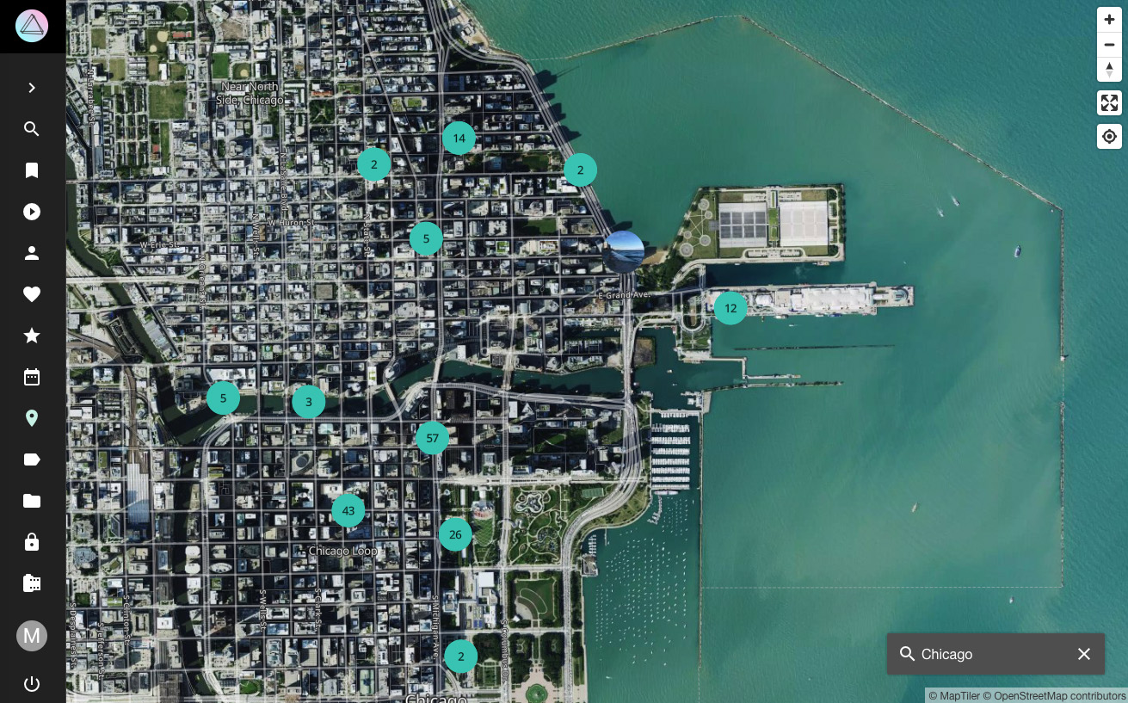

System Requirements
We recommend hosting PhotoPrism on a server with at least 2 cores, 3 GB of physical memory, and a 64-bit operating system. Beyond these minimum requirements, the amount of RAM should match the number of CPU cores.
High-resolution panoramic images may require additional swap space and/or physical memory above the recommended minimum.

Browsers
Our Progressive Web App (PWA) works with most modern browsers, and runs best on Chrome, Chromium, Safari, Firefox, and Edge. You can conveniently install it on the home screen of all major operating systems and mobile devices.
Note that not all video and audio formats can be played with every browser. For example, AAC - the default audio codec for MPEG-4 AVC / H.264 - is supported natively in Chrome, Safari, and Edge, while it is only optionally supported by the OS in Firefox and Opera.

Databases
PhotoPrism is compatible with SQLite 3 and MariaDB 10.5.12+. Official support for MySQL 8 has been discontinued due to a lack of new features and low demand from our users. Support for PostgreSQL is planned for a future release.

Storage
Indexing large photo and video collections significantly benefits from local SSD storage. Especially the conversion of RAW images and the transcoding of videos are very demanding. The use of SSDs as database storage is also highly recommended.

Deployment
We recommend using Docker for running PhotoPrism as it provides a common standard across most operating systems and devices, enabling teams to have the exact same environment everywhere in development, staging, and production. Our stable release and development preview have been built into a single multi-arch image for 64-bit AMD, Intel, and ARM processors, including Raspberry Pi 3 / 4, Apple Silicon, and other ARM64-based devices.
Step-by-step installation instructions can be found on docs.photoprism.app. You are welcome to contact us for other deployment options if needed.

